**Instructions for uploading your code to Git Lab repository**

**Step 1:** You will need to install git and a shell to interact with git. Please follow the below procedures based on your operating system:

* **Windows users**:
  + You will need to install git bash in your windows. Use the link to install git bash: <https://git-scm.com/downloads> ( After you open the link you will need to click on windows to start the download.)
  + After the git bash gets downloaded you will need to install it. Installation is very simple, just click Next button for each window.
* **Ubuntu users**:
  + Open your terminal and execute the command to install git:
    - **sudo apt-get update**
    - **sudo apt-get install git**
* **Mac users**:
  + Please follow the link for installing git in Mac: <https://www.visualstudio.com/learn/install-and-set-up-git/>

**Step 2:** You will need to create a directory and initialize git inside it. After that copy the required code and paste in this directory. Commands are shown below:

* **mkdir sample** ( You can give any name as per your choice)
* **cd sample**
* **git init** (This initializes the git repository)

**Step 3:** Open your edureka account and go to the selenium course. You will get all the links with username and password in the right panel. **(See the screenshot)**

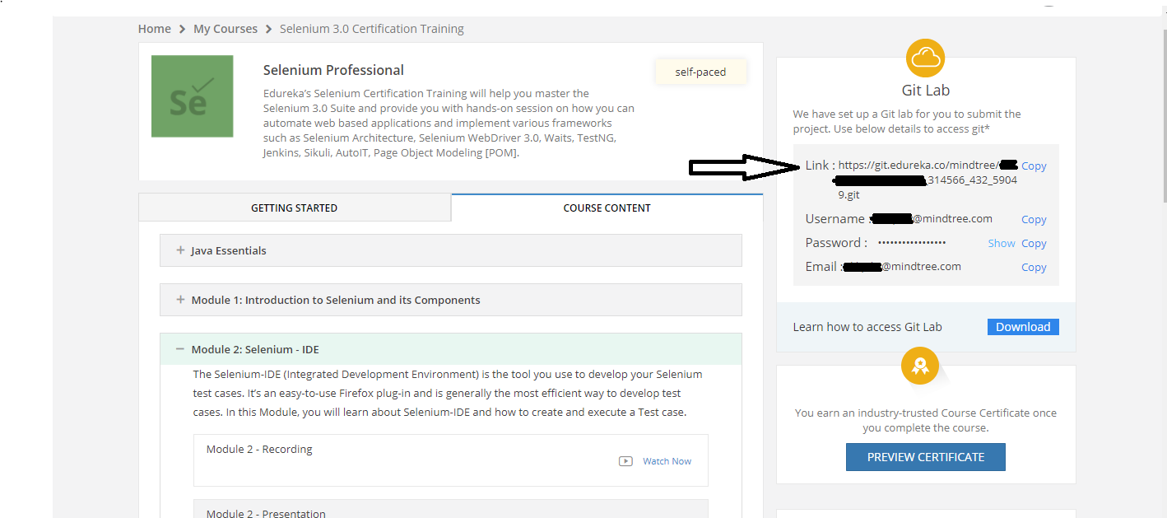

* Open the first link as marked with arrow in the above screenshot, you will the find page of git lab. Use the username and password mentioned in your LMS as shown in the above screenshot to log in.
* Once you log in you will find the page something like this as shown below. Copy the https link and use the link with git clone command in your git terminal.
  + **git clone**

<https://git.edureka.co/mindtree/xxxxxxxmindtreecom_314566_432_59049.git>

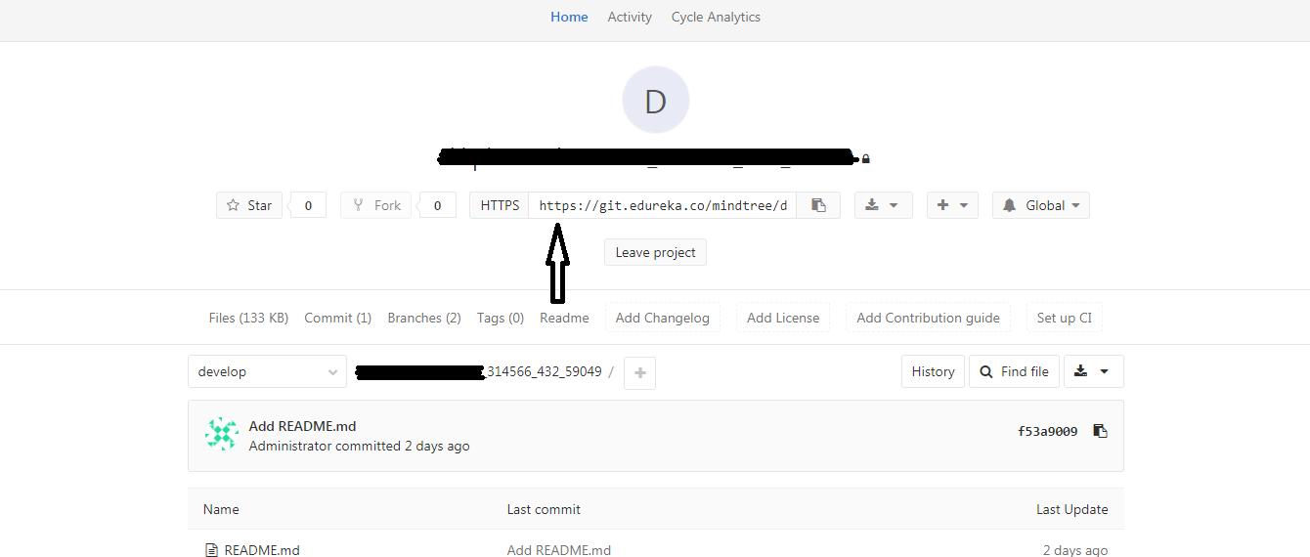

( **Use the https link as marked by the arrow in the git clone command**)

* + After executing the git clone command it will prompt for username and password which will be the same as used for logging into git lab i.e visible in your LMS.

**Step 4:** If you get any certificate error then please execute the below command:

**git config --global http.sslVerify false**

**Step 5:** Once the repo is cloned you will get a folder created. Type **ls** to check. You will get a new folder that gets created after cloning.

Now copy all the files to folder which has been created recently:

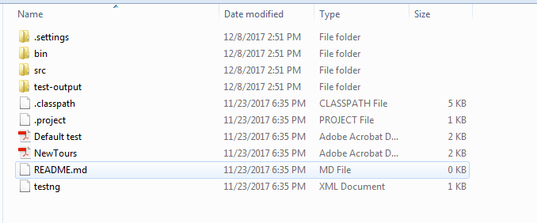

Get inside that folder using **cd** command and follow the commands as mentioned below:

* **git add .** or **git add <file_name>**
* **git commit -m “Describe the intention of your message”**
* **git push -u origin develop**

Step 6: After executing the above commands the codes will get pushed t git lab. To check this open the git lab page and refresh.

**\*\*\*\*NOTE: You will need to push all your codes with its original format. Do not compress any folder or code to .rar or .zip. This will not let the system to generate a ticket on your behalf and let us know about your project submission.**

Feel free to contact us in case of any query. We will be happy to help you.